**Picture:**



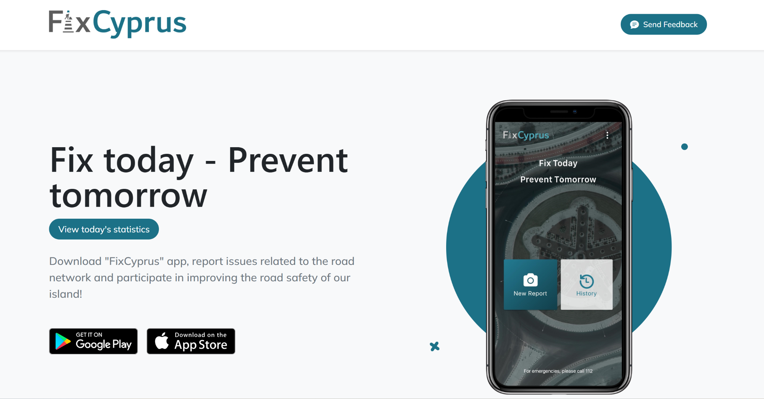

**The title for an urban mobility success story or 'good practice' from your country or city that you are proud of:**

FixCyprus: A platform and mobile app to improve the Cyprus road network infrastructure and road safety

**The description of the story:**

Under the motto "Fix today, prevent tomorrow," the FixCyprus platform and mobile application gathers and handles crowdsourced data about issues with Cyprus' road network with the goal of enhancing both road safety and the infrastructure of the Cyprus road network.

In particular, after registering, any person can use the FixCyprus mobile application to report issues with the road network infrastructure that may affect road safety, including damages, vandalism, and other hazards. These reports may include remarks, a location, and a photo. Depending on the report's geographic area, it will be immediately sent to the Public Works Department's (PWD) associated district office upon submission. The PWD district offices will review the reports via a web portal. If they satisfy the application's requirements, the reports will be forwarded to the appropriate authorities who will handle the issues noted in each report. A web portal will be used to notify the authorities, who will then be in charge of making the required repairs. The FixCyprus app users will be able to track the status of their reports through the app’s report history.

The use of the FixCyprus mob application by citizens is expected to reduce the need for regular road network inspections, to identify the problems in the road network, to strengthen the communication with citizens, and to improve road safety.

**Your arguments explaining why you believe the story you've shared can be considered an urban mobility success story:**

During the 2 years of operations, the statistical data gathered, indicated that the mobile app has been well received and citizens were engaged meaningfully in acknowledging road challenges, reported them and the respective Ministry proceeded to improvements immediately. This is especially significant for fixing cycling paths, addressing issues in the roadworks and more.

**The link (if possible) for more reading:**

<https://www.fixcyprus.cy/>

https://www.kios.ucy.ac.cy/fixcyprus-a-platform-and-mobile-app-to-improve-the-cyprus-road-network-infrastructure-and-road-safety/

MAX. 0,5 page