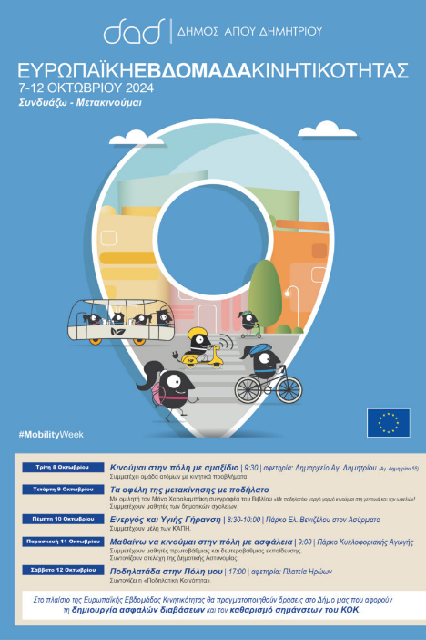

**Picture:**

**The title for an urban mobility success story or 'good practice' from your country or city that you are proud of:** Sustainable Mobility Week in the Municipality of Agios Dimitrios (October 7 to 12)

**The description of the story:** The Municipality of Agios Dimitrios celebrates the Sustainable Mobility Week from October 7 to 12 and invites its residents to leave the car for a while. and to try alternative ways of moving: on foot, by public transport and by bicycle or roller skates, to share the public space with students, the elderly, parents with strollers and the disabled. On the related actions, Mayor Stelios Mamalakis said: "Young and old alike participate in the Sustainable Mobility Week, which is dedicated to the promotion of environmentally friendly modes of transportation. Our goal is to create a safer and more enjoyable environment for everyone. By choosing to walk, cycle or take public transport, we save energy and help create a more sustainable future for our city. We invite you all to the big bike ride that will take place on Saturday, October 12 at 5 pm. starting from Heroes' Square. Let's work together to make our city a better place to live!”

**Your arguments explaining why you believe the story you've shared can be considered an urban mobility success story:** As it aims to make the city safer, more beautiful, more functional and sustainable. Moreover, the current practices help citizens and cities to adopt different alternative modes in sustainable transportation.

**The link (if possible) for more reading:** **https://dad.gr/evdomada-viosimis-kinitikotitas-sto-dimo-agioy-dimitrioy-7-eos-12-oktovrioy/**

MAX. 0,5 page