**Picture:**

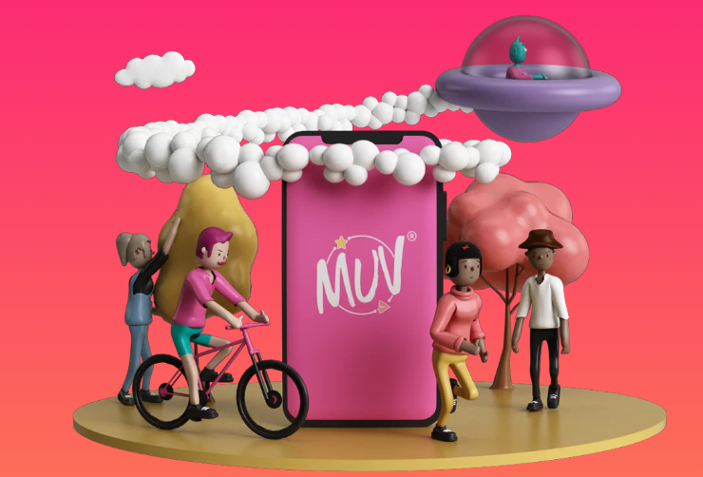

**The title for an urban mobility success story or 'good practice' from your country or city that you are proud of:**

MUV: Safe and Sustainable Mobility is a Team Sport!

**The description of the story:**

The MUV project and App seeks to encourage safe and sustainable mobility thanks to the fact that everyone can play MUV as a professional athlete: from Newbie to Star through training sessions, challenges, tournaments, sponsorships and real gifts. MUV tracks mobility data of those who play in order to design better cities and change bad habits so as to save lungs, heart and the planet and leave a lighter footprint on our planet. But what is innovative in this? That MUV mobility data belongs to the community that has produced it, the participation in the game and timely measurement of impacts contributes to sustainability budgets, welfare projects and mobility plans. Together with those who play, MUV can keep track of Kilometres, Calories and CO2 that are recorded on a weekly average simply by the MUVers that play!

With MUV every single citizen can help build the largest open and collaborative dataset on sustainable mobility.

With the support of Public Administrations, Research Centers and Non-Profit Organizations, open data has already inspired dozens of new solutions to improve urban livability.

**Your arguments explaining why you believe the story you've shared can be considered an urban mobility success story:**

The MUV app has been piloted and developed in Palermo by a local organisation that has believed that the city can change in a positive way and become more sustainable and tailored to human and planet needs. Whether it is a sustainability project for employees or sponsorship for our champions, also companies and organizations can play the game of change as well.

**The link (if possible) for more reading:**

<https://www.muvgame.com/en/>

<https://www.muvgame.com/en/how-it-works/>

<https://www.muvbcorp.com/>

MAX. 0,5 page