**Picture:**

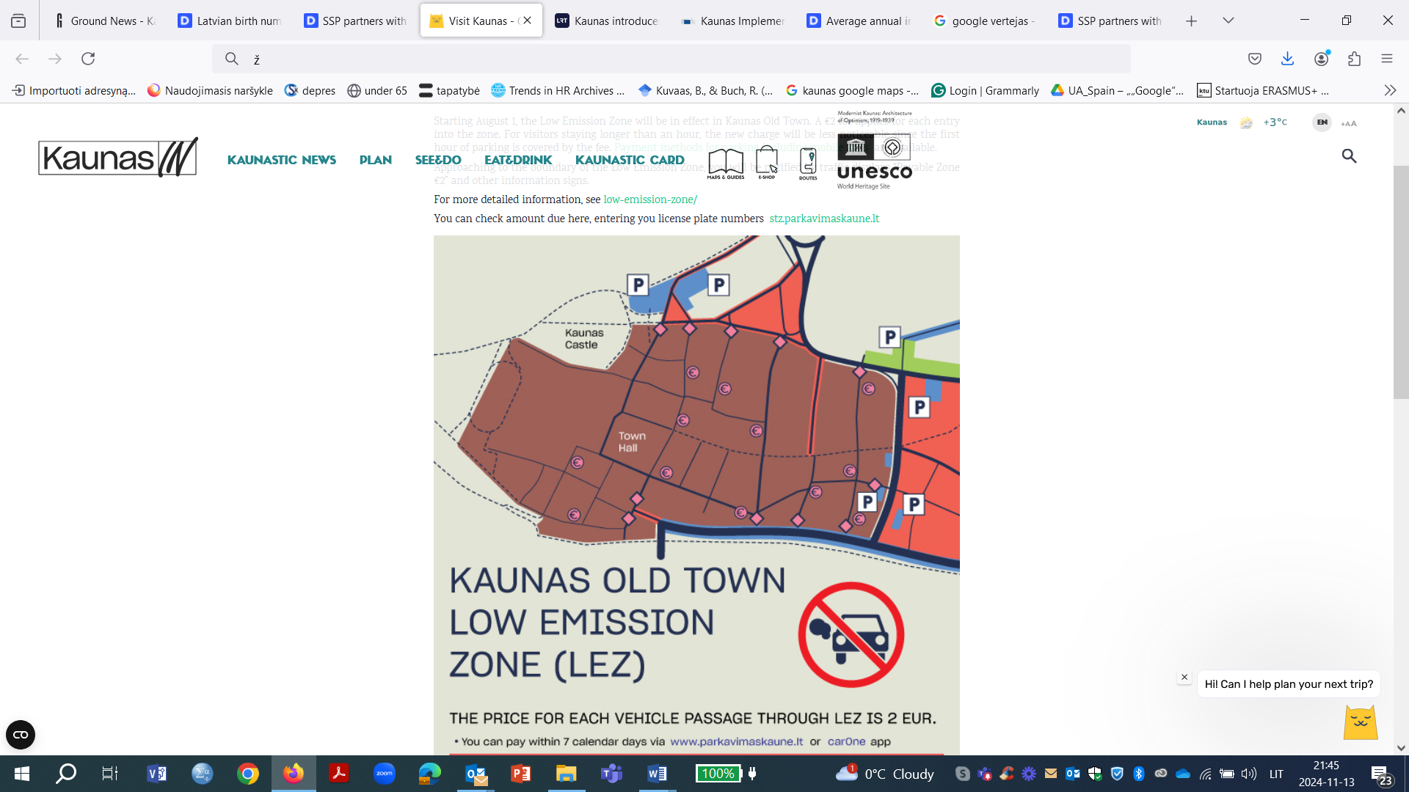

**The title for an urban mobility success story or 'good practice' from your country or city that you are proud of:**

Reducing transit traffic in the old town: Mission Possible or Impossible?

**The description of the story:**

Kaunas, the second-largest city in Lithuania, is well known for its commitment to sustainable urban mobility. The city's main areas of focus include reducing pollution, enhancing cycling infrastructure, increasing pedestrian safety, and making public transport more comfortable and efficient.

Kaunas is bold in promoting and implementing solutions that, at first, may seem out of reach and are sometimes met with resistance from certain residents. One example is the city's ambitious goal to reduce transit traffic in the historic Old Town.

Since August 1, 2004, Kaunas has charged a one-time fee of EUR 2 for cars entering the Old Town low-emission zone. This fee is applied 24 hours a day, 7 days a week, with exemptions for electric vehicles, motorcycles, residents and property owners within the zone, disabled persons, and certain other groups. The municipality believes that this new system will not negatively impact businesses in the city center; on the contrary, the fee is expected to reduce through-traffic, making the area more appealing. However, some business owners and residents remain skeptical.

**The arguments explaining why the story can be considered an urban mobility success story:**

Kaunas is the first city in Lithuania to introduce a low-emission zone. This initiative demonstrates that the city and municipality genuinely care about mobility issues and the quality of life for people living in the old town. Such an initiative can serve as a strong example, encouraging citizens to rethink their mobility habits—especially given that the number of cars entering the old town has already decreased

**The links for more reading:**

[**https://urban-mobility-observatory.transport.ec.europa.eu/resources/case-studies/ramping-infrastructure-walking-and-cycling-kaunas_en**](https://urban-mobility-observatory.transport.ec.europa.eu/resources/case-studies/ramping-infrastructure-walking-and-cycling-kaunas_en)

<https://www.delfi.lt/en/business/kaunas-starts-charging-drivers-for-entering-low-emission-zone-in-old-town-120040484>

<https://urban-mobility-observatory.transport.ec.europa.eu/news-events/news/kaunas-implements-permanent-low-emission-zone-scheme-2024-08-16_en>

<https://visit.kaunas.lt/en/plan/transport/old-town-low-emission-zone/>