**Karlskrona City first in southern Sweden with an electric archipelago boat**

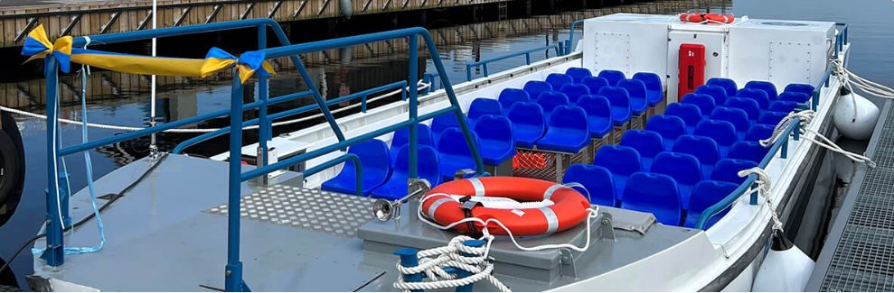

Affärsverken, Karlskrona’s public utility, has launched its first fully electric tour boat, M/F Elleskär, which will operate in Borgmästarefjärden during peak summer months (June to August). Powered entirely by renewable energy, including solar power from Fisktorget, the M/F Elleskär offers a quiet and emission-free experience, contributing to Affärsverken’s goal of becoming fossil-free by 2030. The electric vessel serves a new route from Fisktorget, connecting Pottholmen, Dragsö, and Brändaholm.

The boat's electrification, completed by Hasslö yard, involved the removal of the diesel engine, hull modifications, and design changes. Although initially planned for a 2022 launch, the project was delayed by regulatory processes, making M/F Elleskär the first electric archipelago boat in southern Sweden. The switch to electric power significantly reduces local air and water pollution while minimizing noise, enhancing the experience for the 120,000 annual passengers and numerous chartered tours.

Affärsverken collaborates with marine technology networks, such as Blue Science Park and Skärgårdsredarna, to innovate in sustainable marine practices. While full electrification isn’t feasible for all vessels, Affärsverken explores alternatives like diesel-electric systems and HVO-fueled internal combustion engines to further reduce emissions. Through projects like M/F Elleskär, Affärsverken gains insights into renewable marine technology, advancing their environmental goals for reduced emissions and a balanced marine ecosystem.

**This is an urban mobility success story because t its:**

**Environmental Impact**: M/F Elleskär reduces emissions and noise pollution in an urban waterway, offering a sustainable transit option powered by renewable energy, which aligns with Karlskrona's environmental goals.

**Improved Passenger Experience**: The electric boat provides a quiet, vibration-free ride, enhancing comfort for tourists and commuters alike, which encourages more people to choose sustainable transport over personal vehicles.

**Innovation and Leadership**: Affärsverken’s initiative marks a pioneering shift in Sweden's urban marine transport, demonstrating a successful model for electrification and inspiring further advancements in eco-friendly urban mobility solutions.

**The link (if possible) for more reading:**

https://www.affarsverken.se/skargardstrafiken/

MAX. 0,5 page